**How to install PSNetMon**

***Prerequisites:***

Windows XP Service Pack 3 or higher

IIS Web Server (Internet Information Services)

PowerShell 3.0

Warning this installation requires the Execution Policy for scripts to be unrestricted.

Proceed at your own risk.

**#File copy and PSNetMon Install**

Extract the contents of PSNetMon.zip to c:\inetpub\wwwroot

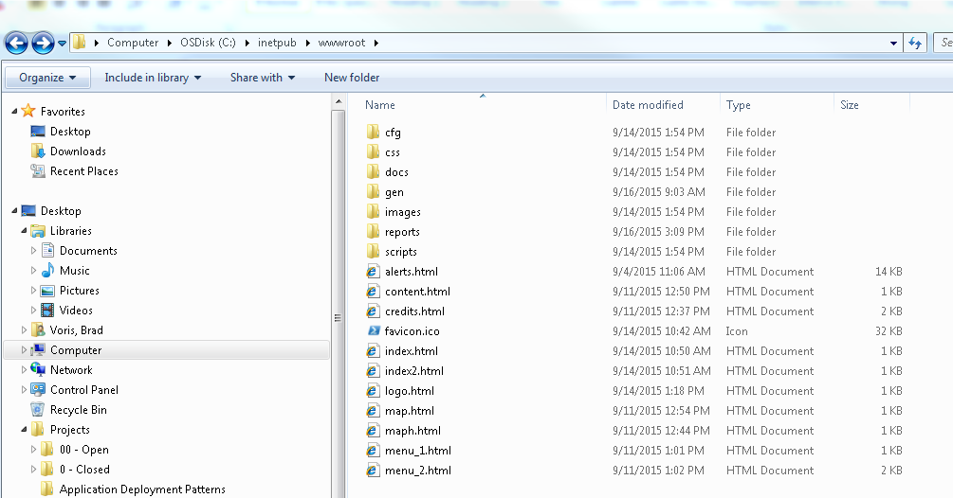

**#File copy and PSNetMon Install Complete**

**#Security Changes**

Go to Start or Windows button



Go to Search, and search for PowerShell ISE

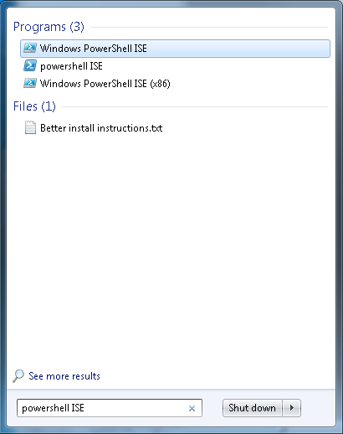

Right-click on Windows PowerShell ISE and select Run as Administrator

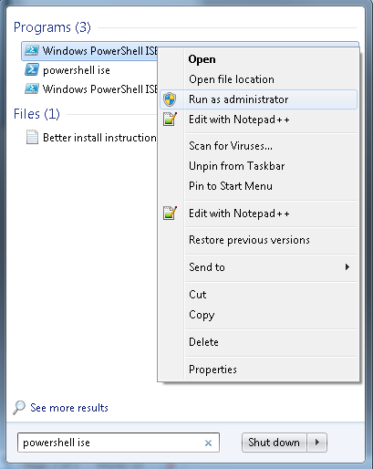

Copy the following line into ISE console

set-ExecutionPolicy unrestricted

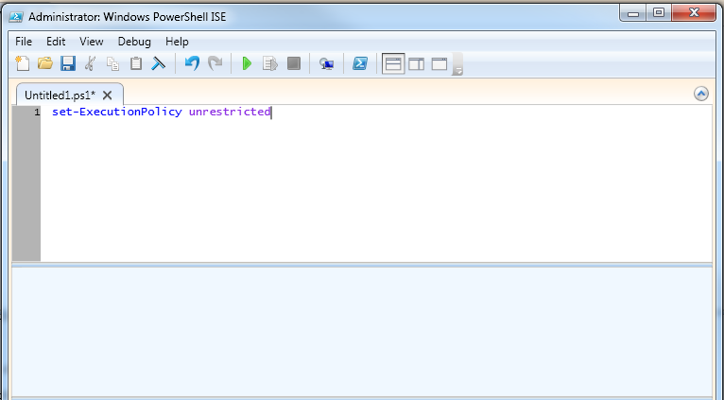

Click the Green arrow (Play button) to run the command

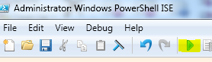

When prompted to run scripts click Yes



**#Security Changes Complete**

**#Setting up the PSNetMon task**

Go to Start or Windows button



Go to Search, and search for Task Scheduler (click on Task Scheduler)

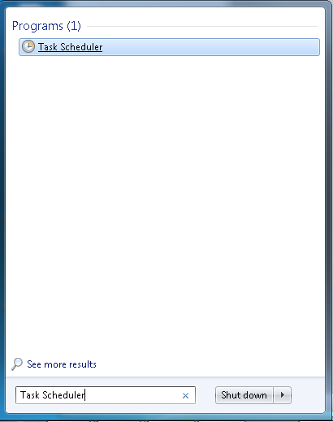

Once Task Scheduler is loaded click on Task Scheduler Library

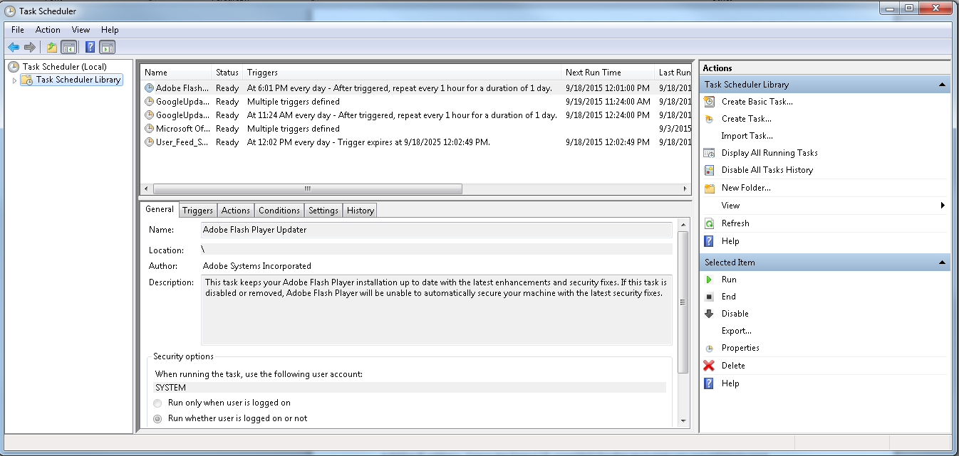

Click Create Task

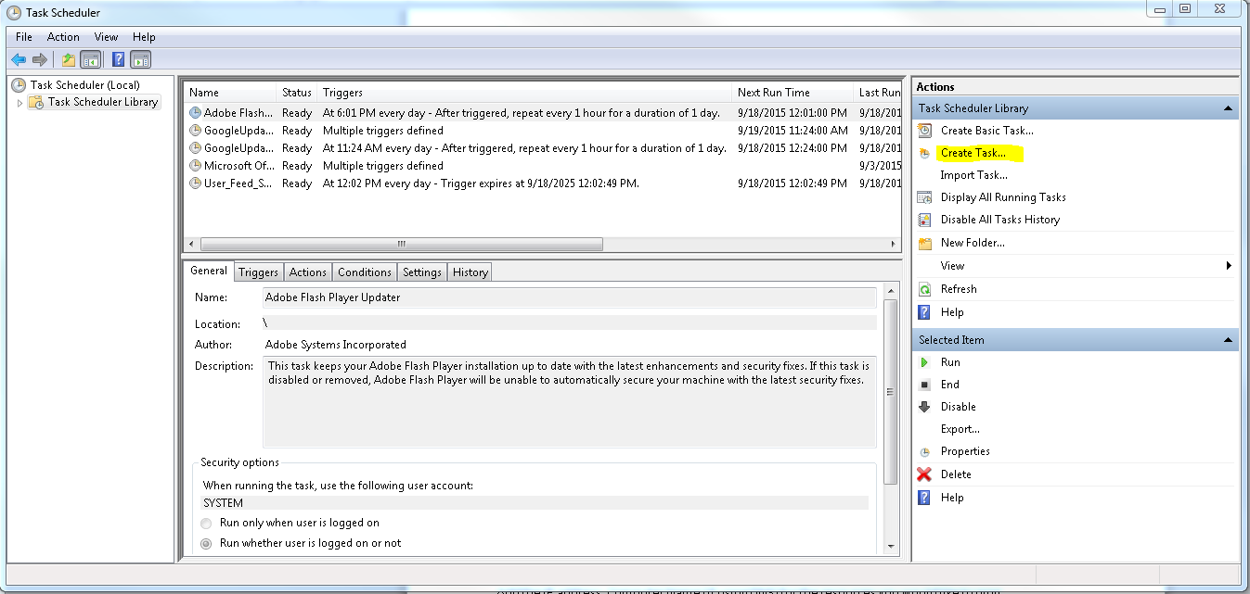

Name the Task PSNetMon Invoker Script (this will differentiate it from any other future scripts added to Task Scheduler)

Copy the following and place in the description:

PSNetMon Invoker Script is run every 5 minutes. This script is a master script list that will call different scripts from PSNetMon in IIS for monitoring network resources.

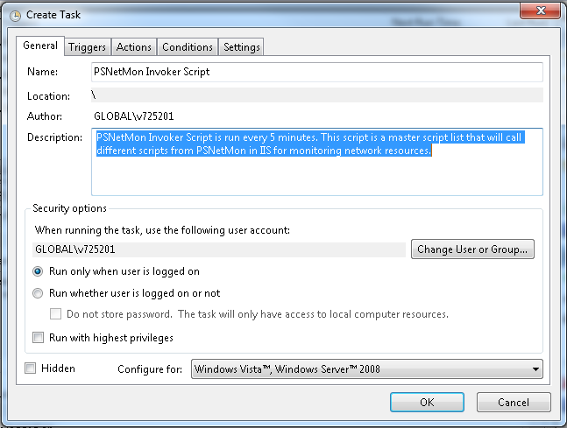

Click Run whether user is logged on or not

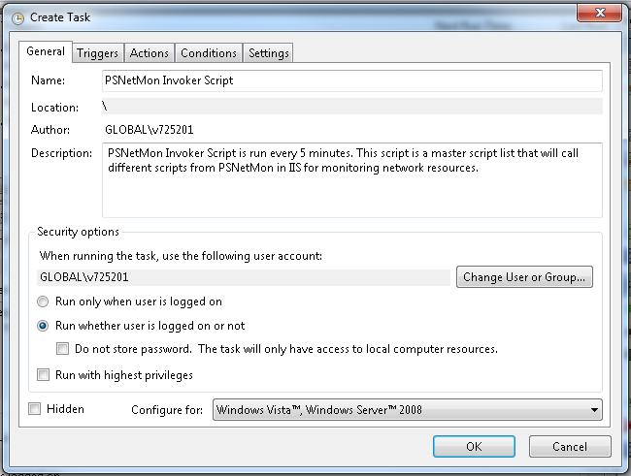

Click Triggers Tab and Click New…

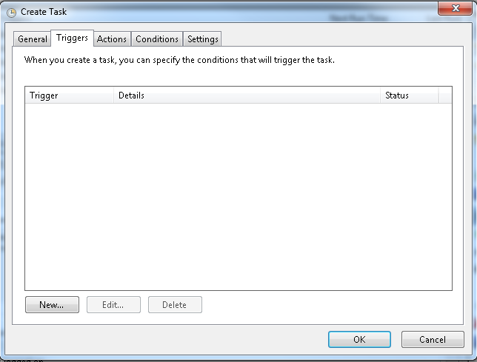

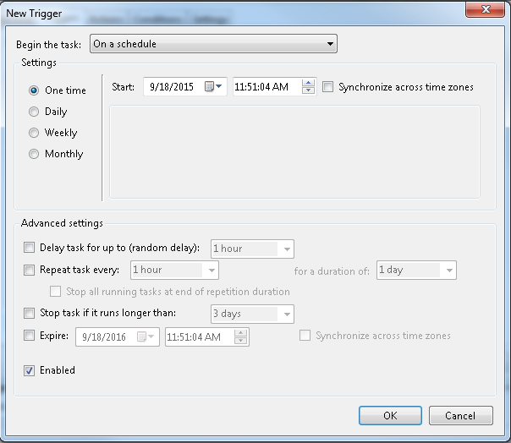

Select Daily

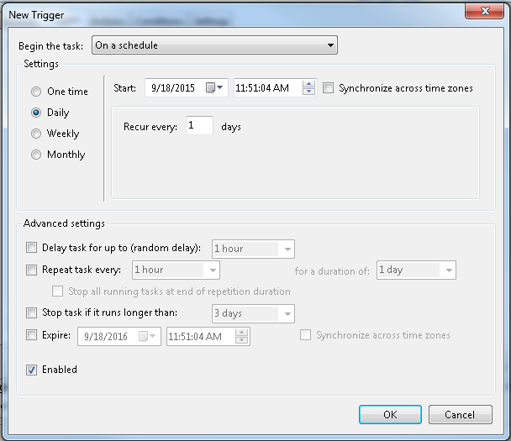

Check the check box for Repeat Task every:

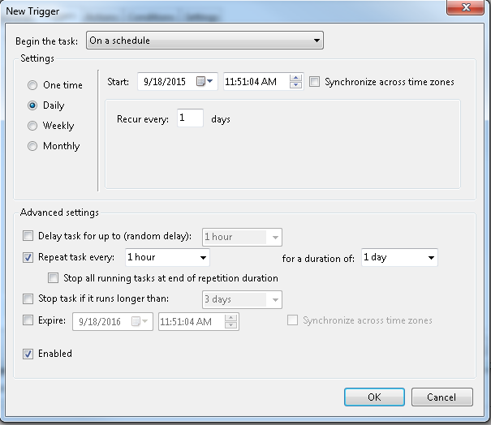

Set task for every 5 minutes for a duration of indefinitely

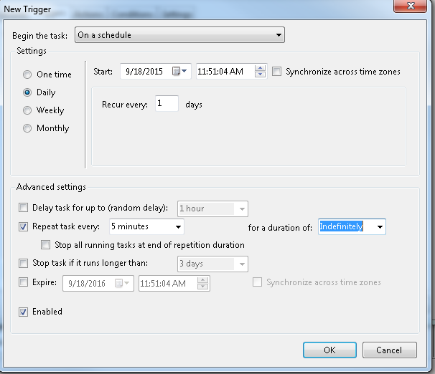

Check box for Stop task if it runs longer than: and change to 2 hours and Click OK

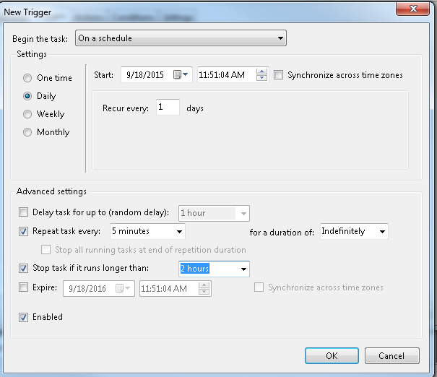

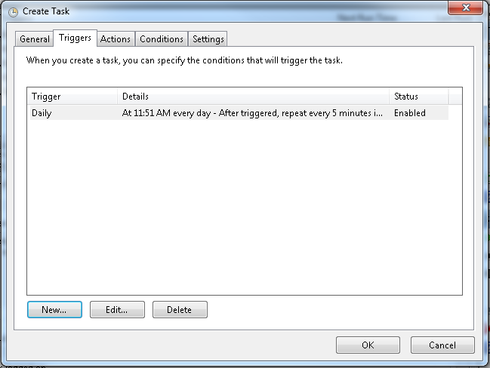

Click Actions Tab

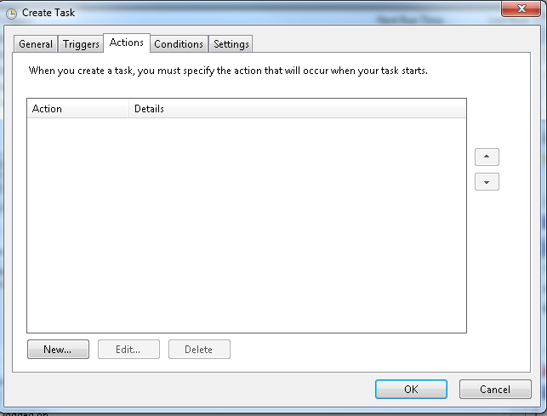

Click New

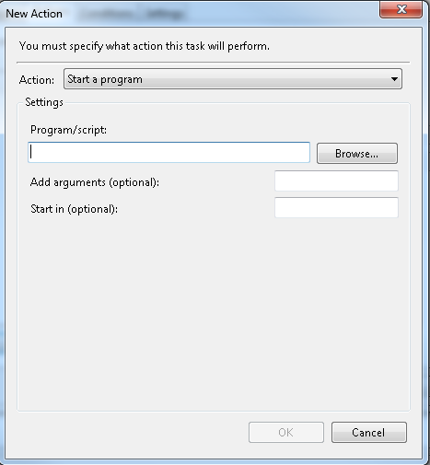

Put Powershell.exe for the Program to run

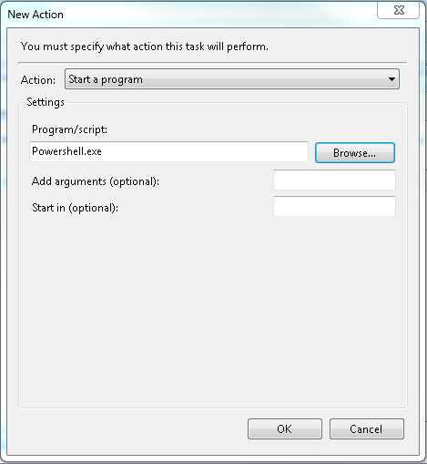

Add Argument C:\inetpub\wwwroot\scripts\PSNetMonInvoker.PS1 and click OK

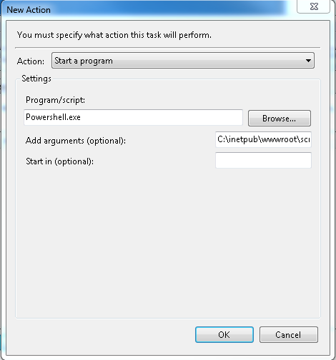

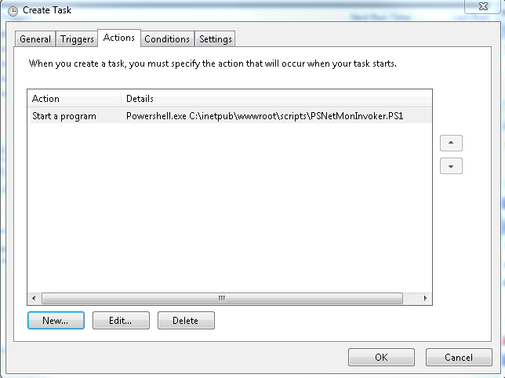

Click Ok

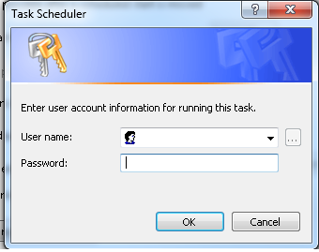

Input username and password for the task

**#Setting up the PSNetMon task Complete**

**#Monitoring Hosts, Ports & Services**

To Customize PSNetMon go to C:\inetpub\wwwroot\cfg

**Monitoring Host Status**

Open computers.cfg in Notepad

Change existing hosts to hosts you would like to see are up I.E: Yahoo.com your server IP address.

Close and save the configuration file.

That resource will now be monitored via an ICMP echo reply or a Ping. Results will update the web page.

**Monitoring Port Status**

Open portcfga.cfg and put the port number of the port you want to monitor (UDP or TCPIP)

Open porthostsa.cfg and put the host name or IP address you want to monitor.

Close and save the configuration file.

That resource will now be monitor via a port query. Results will update the web page.

**Monitoring Service Status**

Open services.cfg and put the name of the service you would like to monitor.

Open servicehosts.cfg and put the name of the computer or IP address you would like to monitor.

Close and save the configuration file.

That resource will now be monitor via a WMI call to validate the service is up. Results will update the web page.

**#Monitoring Hosts, Ports & Services Complete**

**#Advanced PSNetMon Features**

**Changing format of pages**

Go to C:\inetpub\wwwroot\css and modify theme.css as you see fit.

**Changing format of buttons**

Go to C:\inetpub\wwwroot\css and modify button.css as you see fit

**Changing RSS Feeds**

Go to C:\inetpub\wwwroot\scripts and open PSNetMonRSSTicker.ps1 in PowerShell ISE.

Edit URL in line 15 &/or 19 and change to an RSS Feed you prefer.

**Changing the area for Weather & having it update as needed**

Go to C:\inetpub\wwwroot\scripts and open PSNetMonAlertScript.ps1 in PowerShell ISE.

Modify line 27 $zip=77479 and change to your desired zip code

To have weather update you will need to create a separate task in Task Scheduler and run PSNetMonAlertScript.ps1 at your desired frequency. I would suggest no frequently than once a day.

**Removing Cameras or RSS from Alerts Module**

Go to C:\inetpub\wwwroot\scripts and open PSNetMonAlertScript.ps1 in PowerShell ISE.

Remove lines 173 & 175

**Adding personal content to Alerts Module**

Go to C:\inetpub\wwwroot\scripts and open PSNetMonAlertScript.ps1 in PowerShell ISE.

From line 170-176 insert an additional modules or HTML code that you would like. Modules will all be in iframes from now on and will be easily customizable via HTML, CSS and PowerShell.

**#Advanced PSNetMon Features Complete**

Would you like something custom built in PSNetMon?

Contact me through Technet and I’d be happy to review your request.

PSNetMon is provided as is no warranty, use at your own risk.